**Ideation Phase**

**Brainstorm & Idea Prioritization**

|  |  |
| --- | --- |
| Date | 28 June 2025 |
| Team ID | LTVIP2025TMID41140 |
| Project Name | Smart Sorting-Transfer learning for identifying Rotten fruit & Vegetable Classification |
| Maximum Marks | 4 Marks |

**Brainstorm & Idea Prioritization :**

During the brainstorming phase of this project, we explored a variety of ideas aimed at solving the challenge of fruit and vegetable identification. Concepts ranged from smart checkout assistants to home kitchen sorters and even accessibility tools for the visually impaired. After evaluating the impact and feasibility of each, we prioritized solutions that were both technically achievable and offered significant value to users. High-priority ideas like automated retail recognition systems and at-home produce classifiers became the project’s central focus, while more complex or niche concepts were set aside for potential future development.

**Step-1: Team Gathering, Collaboration and Select the Problem Statement**

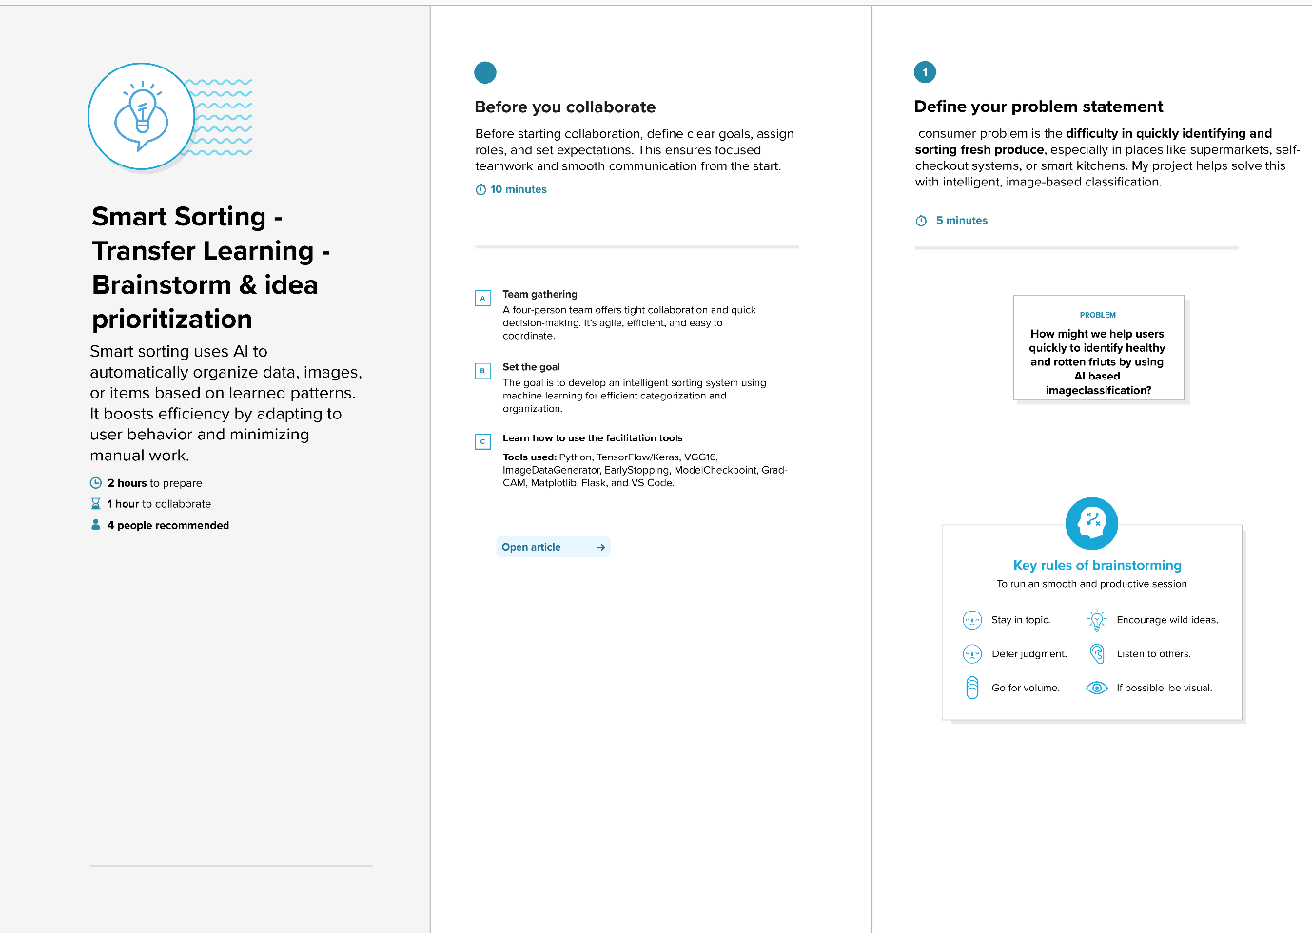

**Step-2: Brainstorm, Idea Listing and Grouping**

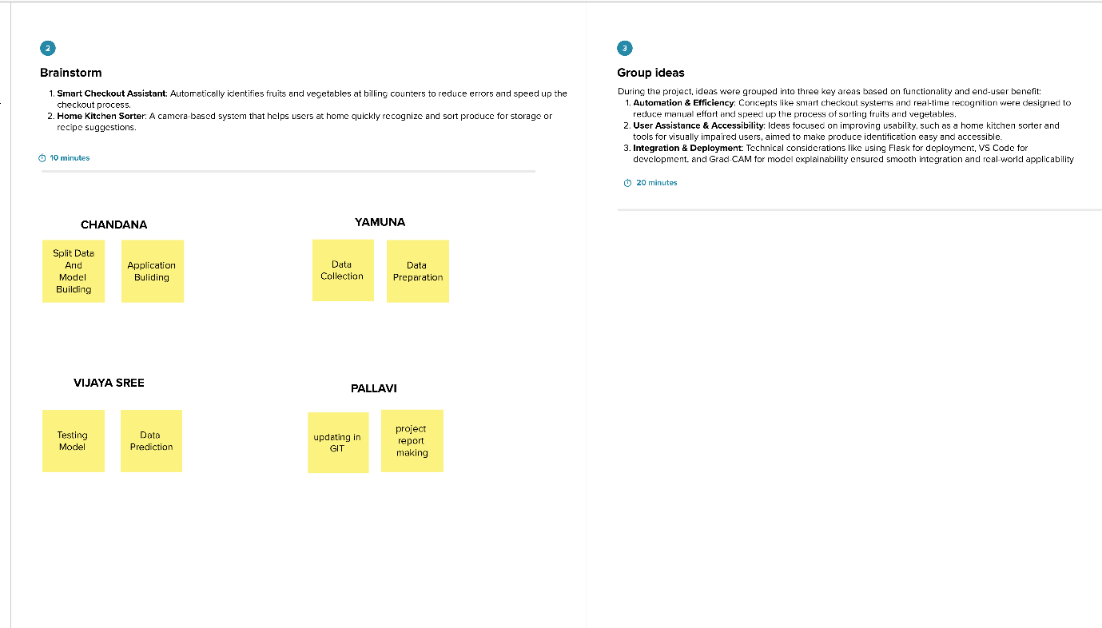

**Step-3: Idea Prioritization**

